**2022503003**

**ASSIGNMENT-4**

**04.09.24**

**Exercise 1: Practice string methods**

Write a java program to perform string methods by considering the given string inputs

String s1=”Welcome to Java”;

String s2=s1;

String s3=new String(“Welcome to Java”);

String s4=s1.intern();

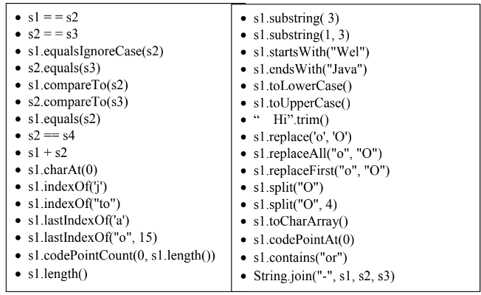

**CODE:**

import java.util.*;

class strIntro{

public static void main(String[] args){

System.out.println("R.Prabhakara Arjun\n2022503003\n");

String s1="Java";

String s2="Java";

String s3=s2;

String s4=new String("Java");

String s5=new String("Java");

String s6=new String("JaVa");

String s7="Java Java va va";

String s8="Abi😊!";

System.out.println("s1==s2:"+(s1==s2));

System.out.println("s1.equals(s2):"+s1.equals(s2));

System.out.println("s2==s3:"+(s2==s3));

System.out.println("s1.equals(s3):"+s1.equals(s3));

System.out.println("s1==s4:"+(s1==s4));

System.out.println("s1.equals(s4):"+s1.equals(s4));

System.out.println("s4==s5:"+(s4==s5));

System.out.println("s5.equals(s4):"+s5.equals(s4));

System.out.println("s1.equals(s6):"+s1.equals(s6));

System.out.println("s1.equalsIgnoreCase(s6):"+s1.equalsIgnoreCase(s6));

System.out.println("s1.compareTo(s6):"+s1.compareTo(s6));

System.out.println("s1+s2:"+(s1+s2));

System.out.println("s4+s5:"+(s4+s5));

System.out.println("s1+s5:"+(s1+s5));

System.out.println("s1.charAt(0):"+s1.charAt(0));

System.out.println("s1.indexOf('a'):"+s1.indexOf('a'));

System.out.println("s1.indexOf(\"av\"):"+s1.indexOf("av"));

System.out.println("s7.lastIndexOf('a'):"+s7.lastIndexOf('a'));

System.out.println("s7.lastIndexOf(\"av\"):"+s7.lastIndexOf("av"));

System.out.println("s7.length():"+s7.length());

System.out.println(s8+"s8.codePointCount(0,s8.length()):"+s8.codePointCount(0,s8.length()));

System.out.println("s1.substring(3):"+s1.substring(3));

System.out.println("s1.substring(3):"+s1.substring(1,3));

System.out.println("s1.substring(3):"+s1.substring(0,s1.length()));

System.out.println("s1.startsWith(\"Jav\"):"+s1.startsWith("Jav"));

System.out.println("s1.endsWith(\"Jav\"):"+s1.endsWith("Jav"));

System.out.println("s1.toLowerCase():"+s1.toLowerCase());

System.out.println(s1);

String s100=s1.toLowerCase();

System.out.println(s100);

System.out.println("s1.toUpperCase():"+s1.toUpperCase());

System.out.println("\" a-b-i \":"+" a-b-i ".trim());

String s99="Helooo hooo";

//System.out.println("s99.replace('o',\"OoOo\"):"+s99.replace('o',"OoOo"));

System.out.println("s99.replace('o',\"O\"):"+s99.replace('o','O'));

System.out.println(s99);

System.out.println("s99.replaceAll(\"o\",\"Ooo\"):"+s99.replaceAll("o","Ooo"));//takesboth as string as a parameter!

System.out.println("s99.replaceFirst(\"o\",\"Ooo\"):"+s99.replaceFirst("o","Ooo"));

System.out.println("s99.split(\"o\"):"+s99.split("o"));

String s98="Helooo hoooO";

System.out.println("Arrays.toString(s99.split(\"o\")):"+(Arrays.toString(s99.split("o"))));

System.out.println("Arrays.toString(s98.split(\"o\")):"+(Arrays.toString(s98.split("o"))));

System.out.println("Arrays.toString(s98.split(\"o\",4)):"+(Arrays.toString(s98.split("o",4))));

System.out.println("Arrays.toString(s98.split(\"o\",3)):"+(Arrays.toString(s98.split("o",3))));//limit is atmost hence limit-1parts as split

System.out.println("s1.toCharArray():"+(s1.toCharArray()));

System.out.println("Array.toString(s1.toCharArrays()):"+Arrays.toString(s1.toCharArray()));

System.out.println(s8+"s8.codePointAt(0):"+s8.codePointAt(0));

System.out.println(s8+"s8.codePointAt(s8.length()-1):"+s8.codePointAt(s8.length()-1));

System.out.println("s1.contains(s2):"+s1.contains(s2));

System.out.println("String.join(\"-\",s1,s2,s3,s4,s5,s6):"+String.join("-",s1,s2,s3,s4,s5,s6));

}

}

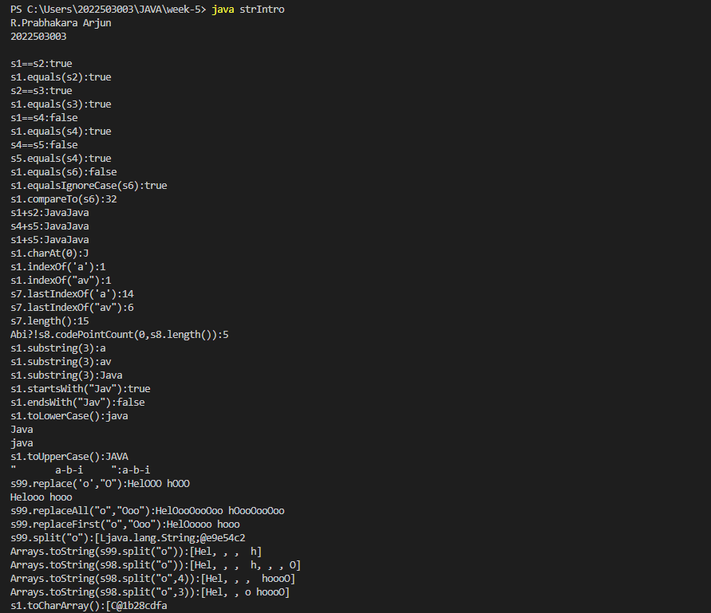

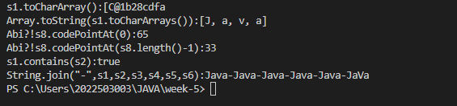

**Exercise 2: String reverse**

Write a java program to read the string and displays the reverse of the string.

Hint: swap first character with last character until half of the string length

**CODE:**

import java.util.*;

class reverseString{

public static void main(String[] args){

System.out.println("R.Prabhakara Arjun\n2022503003\n");

Scanner input=new Scanner(System.in);

System.out.print("Enter input string!!");

String s2=input.nextLine();

String s1="Hello world";

String rev="";

for(char c:s2.toCharArray()){

rev=c+rev;

}

System.out.println("STRING:"+s2+"\nREVERSED STRING:"+rev);

}

}

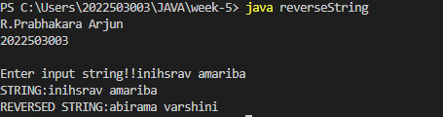

**Exercise 3: Letter occurence**

Write a java program to count the number of occurrence of the each letter in the given string using

single array

Hint: int index = 'b' - 'a'; // indicates index 1

int index = 'c' - 'a'; // indicates index 2

countChar[index]++;

**CODE:**

import java.util.*;

class frequency{

public static void main(String[] args){

System.out.println("R.Prabhakara Arjun\n2022503003\n");

Scanner input=new Scanner(System.in);

System.out.print("Enter input string!!");

String s2=input.nextLine();

//String s1="Hello world";

int[] arrFreq=new int[26];

//System.out.println(Arrays.toString(arrFreq));

for(char c:s2.toLowerCase().toCharArray()){

if(c>='a' && c<='z'){

int index=c-'a';

arrFreq[index]++;

}

}

char[] alpha="abcdefghijklmnopqrstuvwxyz".toCharArray();

System.out.print("\n[");

for(char c:alpha){

System.out.print(c+", ");

}

System.out.print("]\n");

System.out.print(Arrays.toString(arrFreq));

}

}

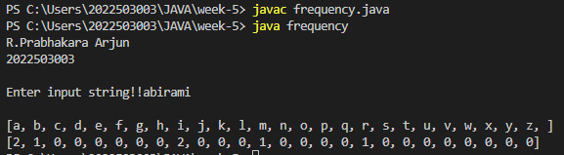

**Exercise 4: string extraction**

Write a java program that extracts all numbers from a given string and returns them as a new string.

For example, "a1b2c3" should return "123"

**CODE:**

import java.util.*;

class stringExtraction{

public static void main(String[] args){

System.out.println("R.Prabhakara Arjun\n2022503003\n");

Scanner input=new Scanner(System.in);

System.out.print("Enter input string!!");

String s2=input.nextLine();

//String s1="123abc456";

String str="";

for(char c:s2.toCharArray()){

if(Character.isDigit(c)){

str=str+c;

}

}

System.out.println(str);

}

}

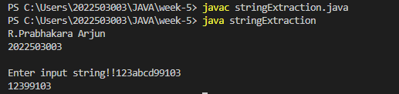

**Excercise 5: Compression**

Write a Java program that performs string compression using the counts of repeated characters.

Example string "aabcccccaaa" would become "a2b1c5a3".

If the "compressed" string would not become smaller than the original string, return the original

string.

**CODE:**

import java.util.*;

class strIntro{

public static void main(String[] args){

System.out.println("R.Prabhakara Arjun\n2022503003\n");

//String s1="aabbcccdddaabbccccc";

Scanner input=new Scanner(System.in);

System.out.print("ENTER THE STRIGN TO BE COMPRESSED:");

String s1=input.nextLine();

String finale="";

int i=0;

while(i<s1.length()){

char curchar=s1.charAt(i);

int count=0;

while(i<s1.length() && s1.charAt(i)==curchar){

count++;

i++;

}

finale+=curchar;

finale+=count;

}

if(finale.length()>s1.length()){

System.out.println(s1);

}

else{

System.out.println(finale);

}

}

}

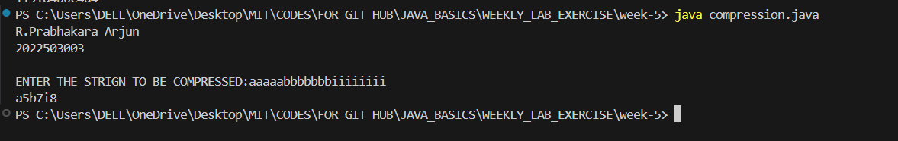

**Exercise 6: Anagram**

Write a java program to check the given string is Anagram or not

Example1 : Listen vs Silent

Example 2 : The Morse Code vs Here Come Dots

**CODE:**

import java.util.*;

class anagram{

public static void main(String[] args){

System.out.println("R.Prabhakara Arjun\n2022503003\n");

/*String s1="abi is beautiful";

String s2="beautiful is abi arjun";*/

//I AM LORD VLODEMORT-------->TOM MARVOLO RIDDLE

Scanner input=new Scanner(System.in);

System.out.print("ENTER STRING1:");

String s1=input.nextLine();

System.out.print("ENTER STRING2:");

String s2=input.nextLine();

char[] a=s1.replace(" ","").toCharArray();

char[] b=s2.replace(" ","").toCharArray();

System.out.println(Arrays.toString(a)+"\n"+Arrays.toString(b));

Arrays.sort(a);

Arrays.sort(b);

System.out.println(Arrays.toString(a)+"\n"+Arrays.toString(b));

if(Arrays.toString(a).length()!=Arrays.toString(b).length()){

System.out.println("Not an anagram");

}

else if(Arrays.toString(a).equals(Arrays.toString(b))){

System.out.println("Is a anagram");

}

else{

System.out.println("Not an anagram");

}

}

}

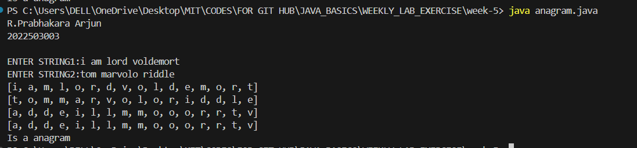

**Exercise 7: Comparison of product version number**

Write a java program that read a two string of the given format and compares the string

Example:

15.10.10 is greater than 14.20.50 as 15 >14

14.12.10 is greater than 14.10.55 as 12>10

14.10.15 is greater than 14.10.11 as 15>11

**CODE:**

Hint: GivenString.import java.util.*;

class productVersionComparison{

public static void main(String[] args){

System.out.println("R.Prabhakara Arjun\n2022503003\n");

Scanner input=new Scanner(System.in);

System.out.println("x.x.x(kindly enter number in this format!)");

System.out.print("ENTER STRING1:");

String s1=input.nextLine();

System.out.print("ENTER STRING2:");

String s2=input.nextLine();

//String s1="12.13.14";

//String s2="12.13.14";

String[] a=s1.split("\\.");

String[] b=s2.split("\\.");

System.out.println(Arrays.toString(a));

System.out.println(Arrays.toString(b));

if(a.length!=b.length){

System.out.println("No comparisons can be mad bruh!!");

return;

}

for(int i=0;i<a.length;i++){

if(Integer.parseInt(a[i])>Integer.parseInt(b[i])){

System.out.println(s1+" is greater!");

return;

}

else if(Integer.parseInt(a[i])<Integer.parseInt(b[i])){

System.out.println(s2+" is greater!");

return;

}

}

System.out.println(s1+" is equal to "+s2);

}

}split(“\\.”). Store each split part in an array and compare

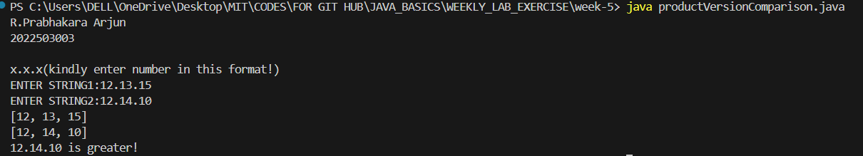

**Exercise 8: Email validity**

Write a java program to compare the email is valid is invalid and retruns the username and domain

name

i) Valid Username: numbers[0-9], alphabets[a-z][A-Z], underscore, hypen and plus characters .

Total number of characters are 25.

ii) Presence of single @ symbol

iii) Presence of domain name .com, .in, .edu

**CODE:**

import java.util.*;

class emailValidity{

public static void main(String[] args){

System.out.println("R.Prabhakara Arjun\n2022503003");

Scanner input=new Scanner(System.in);

System.out.print("ENTER STRING1:");

Boolean[] boo={false,false,false,false,false,false,false};

String s1="Arjun_1-sfdfds910@hamil.com";

System.out.println(Arrays.toString(boo));

if(s1.length()>=25){

boo[boo.length-1]=true;

}

if(s1.contains("_")){

boo[boo.length-2]=true;

}

if(s1.contains("-")){

boo[boo.length-3]=true;

}

if (s1.lastIndexOf('@')==s1.indexOf('@')) {

boo[boo.length - 4] = true;

}

if(s1.endsWith(".com")||s1.endsWith(".in")||s1.endsWith(".edu")){

boo[boo.length-5]=true;

}

if(s1.matches(".*\\d.*")){

boo[0]=true;

}

if(s1.matches(".*[a-zA-Z].*")){

boo[1]=true;

}

System.out.println(Arrays.toString(boo));

String[] messages = {

"The string must contain at least one number.",

"The string must contain at least one alphabet.",

"The string must end with .com, .in, or .edu.",

"The string must contain exactly one '@' symbol.",

"The string must contain a '-' character.",

"The string must contain an '_' character.",

"The string must be at least 25 characters long."

};

int i = 0;

Boolean flag=true;

while (i < boo.length) {

if (!boo[i]) {

System.out.println("Constraint failed: " + messages[i]);

flag=false;

}

i++;

}

if(flag){

String[] a=s1.split("@");

System.out.println("The username is "+a[0]+"\nThe doamin name is "+a[1]);

}

else{

System.out.println("RUN THE PROGRAM AGAIN!!");

}

}

}

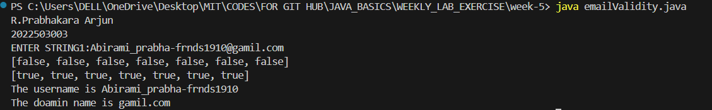

**Exercise 9: Dictionary**

Write a java program to create a dictionary using 2D string array any 10 programming languages.

Write a method that return the definition for the input of PL name.

Java- pure object oriented programming language by James Gosling

**CODE:**

import java.util.*;

class dictionary{

static String[][] dictionaryee = {

{"Java", "Pure object-oriented programming language by James Gosling"},

{"C++", "Object-oriented programming language by Bjarne Stroustrup"},

{"Python", "High-level programming language by Guido van Rossum"},

{"JavaScript", "High-level, interpreted scripting language primarily used in web development"},

{"C", "General-purpose procedural programming language by Dennis Ritchie"},

{"Ruby", "Dynamic, reflective, object-oriented language used for web applications"},

{"Swift", "Powerful and intuitive programming language for iOS and macOS apps"},

{"Go", "Open-source programming language that makes it easy to build simple, reliable software"},

{"Rust", "Systems programming language focused on safety and concurrency"},

{"PHP", "Server-side scripting language primarily used for web development"}

};

public static String getDef(String lang){

for(int i=0;i<dictionaryee.length;i++){

if(dictionaryee[i][0].equalsIgnoreCase(lang)){

return dictionaryee[i][0]+"-->"+dictionaryee[i][1];

}

}

return "LANG NOT FOUND!";

}

public static void main(String[] args){

Scanner input=new Scanner(System.in);

System.out.println("R.Prabhakara Arjun\n2022503003\n");

System.out.print("ENTER THE LANG TO SEARCHED:");

//String s1="java";

String s1=input.nextLine();

String def=getDef(s1);

System.out.println(def);

}

}

